Learning objectives
Define cloud computing.
Describe the shared responsibility model.
Define cloud models, including public, private, and hybrid.
Identify appropriate use cases for each cloud model.
Describe the consumption-based model.
Compare cloud pricing models.

Cloud computing:
Cloud computing is the delivery of computing services over the internet. Computing services include common IT infrastructure such as virtual machines, storage, databases, and networking. Cloud services also expand the traditional IT offerings to include things like Internet of Things (IoT), machine learning (ML), and artificial intelligence (AI)

Shared responsibility model:
With the shared responsibility model, these responsibilities get shared between the cloud provider and the consumer. Physical security, power, cooling, and network connectivity are the responsibility of the cloud provider. The consumer isn’t collocated with the datacenter, so it wouldn’t make sense for the consumer to have any of those responsibilities.
At the same time, the consumer is responsible for the data and information stored in the cloud. (You wouldn’t want the cloud provider to be able to read your information.) The consumer is also responsible for access security, meaning you only give access to those who need it.
With an on-premises datacenter, you’re responsible for everything.
=>IaaS places the most responsibility on the consumer, with the cloud provider being responsible for the basics of physical security, power, and connectivity.
=>SaaS places most of the responsibility with the cloud provider.
=> PaaS, being a middle ground between IaaS and SaaS, rests somewhere in the middle and evenly distributes responsibility between the cloud provider and the consumer.

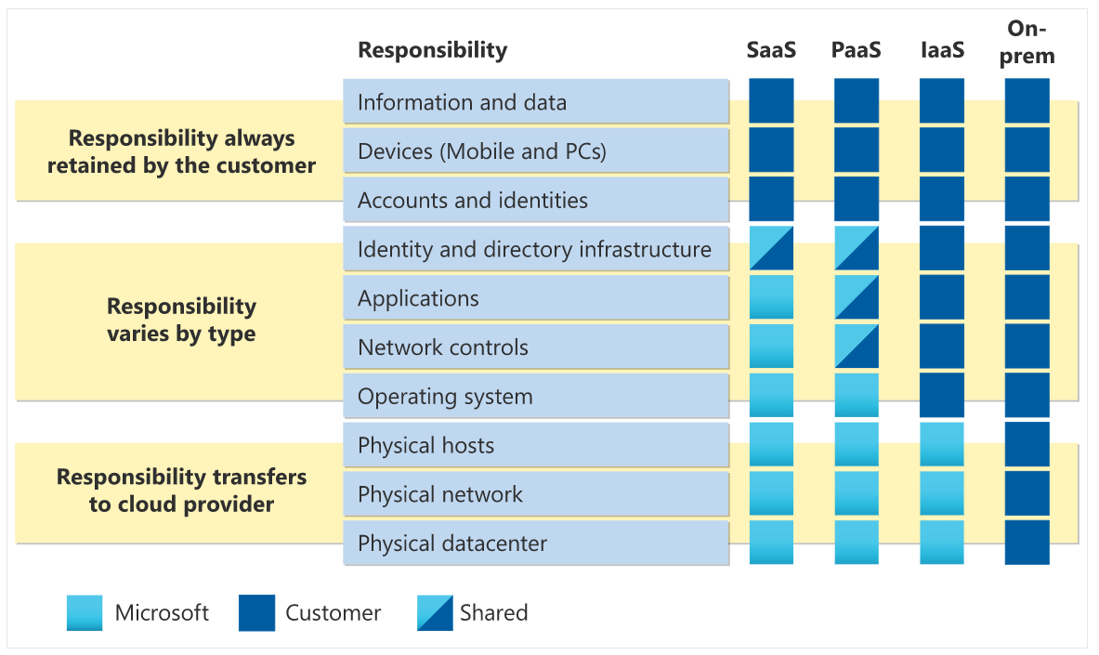

Cloud Model:
Private cloud: A private cloud is, in some ways, the natural evolution from a corporate datacenter.
Public cloud: With a public cloud, anyone that wants to purchase cloud services can access and use resources
Hybrid cloud: A hybrid cloud environment can be used to allow a private cloud to surge for increased, temporary demand by deploying public cloud resources. It can be used to provide an extra layer of security.
Multi-Cloud: In a multi-cloud scenario, you use multiple public cloud providers. Maybe you use different features from different cloud provider or may be in the process of migrating to a different provider.
Azure Arc: Azure Arc is a set of technologies that helps manage your cloud environment. All the above models are managed.
Azure VMWare solutions: Azure VMware Solution lets you run your VMware workloads in Azure CLOUD with seamless integration and scalability.

consumption-based model:
Two types of expenses in IT infrastructure models:
Capital expenditure (CapEx): a one-time, up-front expenditure to purchase or secure tangible resources. A new building, repaving the parking lot, building a datacenter, or buying a company vehicle are examples of CapEx.
Operational expenditure (OpEx): spending money on services or products over time. Renting a convention center, leasing a company vehicle, or signing up for cloud services are all examples of OpEx.
Cloud computing falls under OpEx because cloud computing operates on a consumption-based model.

Learning objectives
Upon completion of this module, you will be able to:
- Describe the benefits of high availability and scalability in the cloud.
- Describe the benefits of reliability and predictability in the cloud.
- Describe the benefits of security and governance in the cloud.
- Describe the benefits of manageability in the cloud.

High Availability: High availability focuses on ensuring maximum availability, regardless of disruptions or events that may occur, when you’re deploying an application, a service, or any IT resources. These guarantees are part of the service-level agreements (SLAs). Each service has different %’s like (99% and 99.9% and 99.965% etc.,)
Scalability: If you suddenly experience peak traffic and your systems are overwhelmed, the ability to scale means you can add more resources to better handle the increased demand.
- Vertical scaling is focused on increasing or decreasing the capabilities of resources.
- Horizontal scaling is adding or subtracting the number of resources.

Reliability and predictability in the cloud
Reliability: It is the ability of a system to recover from failures and continue to function. It's also one of the pillars of the Microsoft Azure Well-Architected Framework.
Predictability: Both performance and cost predictability are heavily influenced by the Microsoft Azure Well-Architected Framework.
- Performance predictability focuses on predicting the resources needed to deliver a positive experience for your customers. Autoscaling, load balancing, and high availability are just some of the cloud concepts that support performance predictability.
- Cost predictability: By operating in the cloud and using cloud analytics and information, you can predict future costs and adjust your resources as needed. You can even use tools like the Total Cost of Ownership (TCO) or Pricing Calculator to get an estimate of potential cloud spend.

Security and Governance in the cloud
Whether you’re deploying infrastructure as a service or software as a service, cloud features support governance and compliance. Things like set templates help ensure that all your deployed resources meet corporate standards and government regulatory requirements.

Manageability in the cloud
Management of the cloud: speaks to managing your cloud resources
- Automatically scale resource deployment based on need.
- Deploy resources based on a preconfigured template, removing the need for manual configuration.
- Monitor the health of resources and automatically replace failing resources.
- Receive automatic alerts based on configured metrics, so you’re aware of performance in real time.

Management in the cloud: speaks to how you’re able to manage your cloud environment and resources.
- Through a web portal.
- Using a command line interface.
- Using APIs.
- Using PowerShell.

cloud service types
IaaS: In an IaaS model, the cloud provider is responsible for maintaining the hardware, network connectivity (to the internet), and physical security. You’re responsible for everything else: operating system installation, configuration, and maintenance; network configuration; database and storage configuration; and so on.
PaaS: In a PaaS environment, the cloud provider maintains the physical infrastructure, physical security, and connection to the internet. They also maintain the operating systems, middleware, development tools, and business intelligence services that make up a cloud solution. In a PaaS scenario, you don't have to worry about the licensing or patching for operating systems and databases.
Development framework: Cloud features such as scalability, high-availability, and multi-tenant capability are included, reducing the amount of coding that developers must do.
Analytics and Business decisions: allow organizations to analyze and mine their data, finding insights and patterns and predicting outcomes to improve forecasting, product design decisions, investment returns, and other business decisions.
SaaS: With SaaS, you’re essentially renting or using a fully developed application. Email, financial software, messaging applications, and connectivity software are all common examples of a SaaS implementation.

Core Architecture and Components of Azure

What does Azure offers: Azure provides artificial intelligence (AI) and machine-learning (ML) services that can naturally communicate with your users through vision, hearing, and speech. It also provides storage solutions that dynamically grow to accommodate massive amounts of data.

Datacentres -> 1 or many DC in Regions
-> 1 or many DC separated within the Regions to form AZ.
Availability zones are primarily for VMs, managed disks, load balancers, and SQL databases. Azure services that support availability zones fall into three categories:
- Zonal services: You pin the resource to a specific zone (for example, VMs, managed disks, IP addresses).
- Zone-redundant services: The platform replicates automatically across zones (for example, zone-redundant storage, SQL Database).
- Non-regional services: Services are always available from Azure geographies and are resilient to zone-wide outages as well as region-wide outages.

Region Pairs: Most Azure regions are paired with another region within the same geography (such as US, Europe, or Asia). This approach allows for the replication of resources across a geography that helps reduce the likelihood of interruptions because of events such as natural disasters, civil unrest, power outages, or physical network outages that affect an entire region.

**To ensure resiliency, a minimum of three separate availability zones are present in all availability zone-enabled
**Not all Azure services automatically replicate data or automatically fall back from a failed region to cross-replicate to another enabled region. In these scenarios, recovery and replication must be configured by the customer.
Sovereign Regions: Sovereign regions are instances of Azure that are isolated from the main instance of Azure. You may need to use a sovereign region for compliance or legal purposes.

Azure Management Group: Resources are gathered into resource groups, and resource groups are gathered into subscriptions. Azure management groups provide a level of scope above subscriptions.

Subscription:
In Azure, subscriptions are a unit of management, billing, and scale. Similar to how resource groups are a way to logically organize resources, subscriptions allow you to logically organize your resource groups and facilitate billing.
AND
An Azure subscription is a logical container used to provision resources in Azure. It holds the details of all your resources like virtual machines (VMs), databases, and more. When you create an Azure resource like a VM, you identify the subscription it belongs to. As you use the VM, the usage of the VM is aggregated and billed monthly.

Azure compute and networking services

Azure virtual desktop: Azure Virtual Desktop is a desktop and application virtualization service that runs on the cloud. It enables you to use a cloud-hosted version of Windows from any location. With it, the data and apps are separated from the local hardware. The actual desktop and apps are running in the cloud, meaning the risk of confidential data being left on a personal device is reduced.
Containers: Much like running multiple virtual machines on a single physical host, you can run multiple containers on a single physical or virtual host.
**VM virtualize the H/w, a Container virtualize the OS.
Azure Function: Azure Functions is an event-driven, serverless compute option that doesn’t require maintaining virtual machines or containers. If you build an app using VMs or containers, those resources have to be “running” in order for your app to function. With Azure Functions, an event wakes the function, alleviating the need to keep resources provisioned when there are no events.
Functions scale automatically based on demand, so they may be a good choice when demand is variable.
Functions are commonly used when you need to perform work in response to an event (often via a REST request), timer, or message from another Azure service, and when that work can be completed quickly, within seconds or less.
Functions can be either stateless or stateful. When they're stateless (the default), they behave as if they're restarted every time they respond to an event.
Functions are a key component of serverless computing.
Hosting options:
Apart from VM and containers, we have Azure APP service, App Service enables you to build and host web apps, background jobs, mobile back-ends, and RESTful APIs in the programming language of your choice without managing infrastructure. Azure App Service is a robust hosting option. It focus on building and maintaining your app, and Azure focuses on keeping the environment up and running.
Types of App Services:
- Web apps
- API apps
- WebJobs
- Mobile apps

Azure virtual networks and virtual subnets enable Azure resources, such as VMs, web apps, and databases, to communicate with each other, with users on the internet, and with your on-premises client computers. You can think of an Azure network as an extension of your on-premises network with resources that link other Azure resources.

Network Peering allows two virtual networks to connect directly to each other. Network traffic between peered networks is private only, and travels on the Microsoft backbone network, never entering the public internet.

Azure VPN: A virtual private network (VPN) uses an encrypted tunnel within another network. VPNs are typically deployed to connect two or more trusted private networks to one another over an untrusted network (typically the public internet). Traffic is encrypted while traveling over the untrusted network to prevent eavesdropping or other attacks.
VPN Gateway: A type of virtual n/w gateway. There are of two types 1) Policy-based 2) Route-based. Use a route-based VPN gateway if you need any of the following types of connectivity:
- Connections between virtual networks
- Point-to-site connections
- Multisite connections
- Coexistence with an Azure ExpressRoute gateway

High availability and fault scenarios:
If you’re configuring a VPN to keep your information safe, you also want to be sure that it’s a highly available and fault tolerant VPN configuration. There are a few ways to maximize the resiliency of your VPN gateway.
- Active/Standby
- Active/active
- Express-Route failover.

Zone-redundant gateways: In regions that support availability zones, VPN gateways and ExpressRoute gateways can be deployed in a zone-redundant configuration. This configuration brings resiliency, scalability, and higher availability to virtual network gateways.
Azure ExpressRoute lets you extend your on-premises networks into the Microsoft cloud over a private connection, with the help of a connectivity provider. Connectivity can be from an any-to-any (IP VPN) network, a point-to-point Ethernet network, or a virtual cross-connection through a connectivity provider at a colocation facility. ExpressRoute connections don't go over the public Internet. Even if you have an ExpressRoute connection, DNS queries, certificate revocation list checking, and Azure Content Delivery Network requests are still sent over the public internet.

ExpressRoute enables direct access to the following services in all regions:
- Microsoft Office 365
- Microsoft Dynamics 365
- Azure compute services, such as Azure Virtual Machines
- Azure cloud services, such as Azure Cosmos DB and Azure Storage

ExpressRoute supports four models that you can use to connect your on-premises network to the Microsoft cloud:
- CloudExchange colocation
- Point-to-point Ethernet connection
- Any-to-any connection
- Directly from ExpressRoute sites

DNS: Azure DNS uses anycast networking, so each DNS query is answered by the closest available DNS server to provide fast performance and high availability for your domain.
***You can't use Azure DNS to buy a domain name. For an annual fee, you can buy a domain name by using App Service domains or a third-party domain name registrar. Once purchased, your domains can be hosted in Azure DNS for record management.

Azure Storage Service:
Locally Redundant Storage: LRS is the lowest-cost redundancy option and offers the least durability compared to other options. Maintains 3 copies of data in a single datacenter. 11 nines of durability.
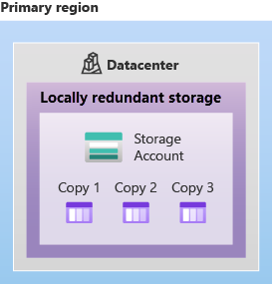
Zone redundant storage: replicates your Azure Storage data synchronously across three Azure (AZ’s) availability zones in the primary region. 12 nines of durability.
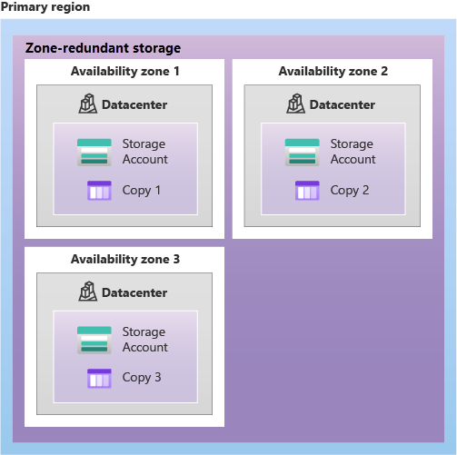
Azure Storage offers two options for copying your data to a secondary region: GRS is similar to running LRS in two regions, and GZRS is similar to running ZRS in the primary region and LRS in the secondary region.
- geo-redundant storage (GRS): GRS copies your data synchronously three times within a single physical location in the primary region using LRS. It then copies your data asynchronously to a single physical location in the secondary region (the region pair) using LRS. 16 nines of durability
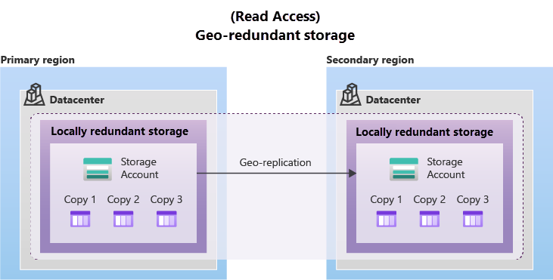
- geo-zone-redundant storage (GZRS): Data in a GZRS storage account is copied across three Azure availability zones in the primary region (similar to ZRS) and is also replicated to a secondary geographic region, using LRS, for protection from regional disasters. 16 nines of durability
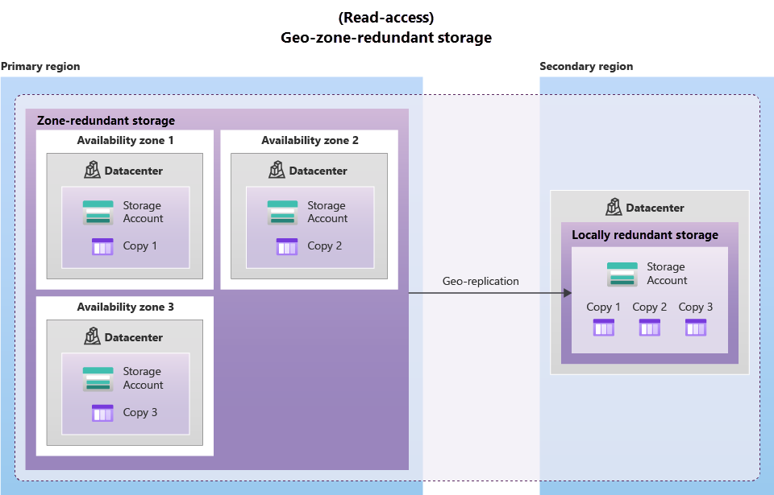

Storage Service
Blob Storage can manage thousands of simultaneous uploads, massive amounts of video data, constantly growing log files, and can be reached from anywhere with an internet connection.

3 tiers of Azure blob storage
- Hot access tier: data that is accessed frequently (eg: images for your website).
- Cool access tier: data that is infrequently accessed and stored for at least 30 days (eg: invoices for your customers).
- Archive access tier: Appropriate for data that is rarely accessed and stored for at least 180 days, with flexible latency requirements (eg: long-term backups)

Azure Files: Azure Files offers fully managed file shares in the cloud that are accessible via the industry standard Server Message Block (SMB) or Network File System (NFS) protocols.
Azure Queue Storage is a service for storing large numbers of messages. Each individual message can be up to 64 KB in size. you could use Azure Functions to trigger an action once the message was received.
Disk storage, or Azure managed disks, are block-level storage volumes managed by Azure for use with Azure VMs. Conceptually, they’re the same as a physical disk, but they’re virtualized.

Azure data migration options: Azure supports both real-time migration of infrastructure, applications, and data using Azure Migrate as well as asynchronous migration of data using Azure Data Box.
Azure Migrate is a service that helps you migrate from an on-premises environment to the cloud.
Azure Data Box is a physical migration service that helps transfer large amounts of data in a quick, inexpensive, and reliable way. The secure data transfer is accelerated by shipping you a proprietary Data Box storage device that has a maximum usable storage capacity of 80 terabytes. The Data Box is transported to and from your datacenter via a regional carrier. A rugged case protects and secures the Data Box from damage during transit. Data Box is ideally suited to transfer data sizes larger than 40 TBs.

Azure also has tools designed to help you move or interact with individual files or small file groups. Among those tools are
AzCopy:
  - AzCopy is a command-line utility that you can use to copy blobs or files to or from your storage account
  - Works with different cloud provider.
  - one-direction synchronization between source and destination copy location.

Azure Storage Explorer: Is a graphical interface and uses AzCopy in backend.
Azure File Sync: Azure File Sync is a tool that lets you centralize your file shares in Azure Files and keep the flexibility, performance, and compatibility of a Windows file server. It’s almost like turning your Windows file server into a miniature content delivery network. Once you install Azure File Sync on your local Windows server, it will automatically stay bi-directionally synced with your files in Azure.

Azure identity, access, and security
Azure AD users?
IT admins. App developers, users, online service subscribers (office 365, CRM online etc)
Azure AD provides.
Authentication | Single Sign On (SSO) | Application mgmt. | Device mgmt (AD registers devices)

connect my on-premises AD with Azure AD: Azure AD Connect synchronizes user identities between on-premises Active Directory and Azure AD. Azure AD Connect synchronizes changes between both identity systems, so you can use features like SSO, multifactor authentication, and self-service password reset under both systems.

Azure AD DS: Azure Active Directory Domain Services (Azure AD DS) is a service that provides managed domain services such as domain join, group policy, lightweight directory access protocol (LDAP), and Kerberos/NTLM authentication. Just like Azure AD lets you use directory services without having to maintain the infrastructure supporting it, with Azure AD DS, you get the benefit of domain services without the need to deploy, manage, and patch domain controllers (DCs) in the cloud.
=> It uses a unique namespace to a managed Azure AD DS domains. This namespace is the domain name. Two Windows Server domain controllers are then deployed into your selected Azure region. This deployment of DCs is known as a replica set.

Authentication: Azure supports multiple authentication methods, including standard passwords, single sign-on (SSO), multifactor authentication (MFA), and passwordless.

Multifactor authentication provides additional security
- Something the user knows – this might be a challenge question.
- Something the user has – this might be a code that's sent to the user's mobile phone.
- Something the user is – this is typically some sort of biometric property, such as a fingerprint or face scan.

Microsoft global Azure and Azure Government offer the following three passwordless authentication options that integrate with Azure AD.
- Windows Hello for Business: Windows Hello for Business is ideal for information workers that have their own designated Windows PC. The biometric and PIN credentials are directly tied to the user's PC
- Microsoft Authenticator app: The Authenticator App turns any iOS or Android phone into a strong, passwordless credential. Users can sign-in to any platform or browser by getting a notification to their phone
- FIDO2 security keys: FIDO allows users and organizations to leverage the standard to sign-in to their resources without a username or password by using an external security key or a platform key built into a device.

Azure external identities: Following capabilities makeup External identities.
- Business to business (B2B) collaboration - B2B collaboration users are represented in your directory, typically as guest users.
- B2B direct connect - Establish a mutual, two-way trust with another Azure AD organization for seamless collaboration.
- Azure AD business to customer (B2C) - Publish modern SaaS apps or custom-developed apps (excluding Microsoft apps) to consumers and customers, while using Azure AD B2C for identity and access management.

Azure conditional access: Conditional Access is a tool that Azure Active Directory uses to allow (or deny) access to resources based on identity signals. These signals include who the user is, where the user is, and what device the user is requesting access from.

Azure role-based access control (RBAC): Azure provides built-in roles that describe common access rules for cloud resources. You can also define your own roles. Each role has an associated set of access permissions that relate to that role. When you assign individuals or groups to one or more roles, they receive all the associated access permissions.
=>How RBAC is applied to resources?
A) Role-based access control is applied to a scope, which is a resource or set of resources that this access applies to.
=>How RBAC is enforced?
A) Azure RBAC is enforced on any action that's initiated against an Azure resource that passes through Azure Resource Manager. Resource Manager is a management service that provides a way to organize and secure your cloud resources.

Zero Trust Model: Zero Trust is a security model that assumes the worst case scenario and protects resources with that expectation. Zero Trust assumes breach at the outset, and then verifies each request as though it originated from an uncontrolled network.
Zero Trust security model- guiding principles:
- Verify explicitly - Always authenticate and authorize based on all available data points.
- Use least privilege access - Limit user access with Just-In-Time and Just-Enough-Access (JIT/JEA), risk-based adaptive policies, and data protection.
- Assume breach - Minimize blast radius and segment access. Verify end-to-end encryption. Use analytics to get visibility, drive threat detection, and improve defenses.

defense-in-depth: The objective of defense-in-depth is to protect information and prevent it from being stolen by those who aren't authorized to access it. It uses a series of mechanisms to slow the advance of an attack that aims at acquiring unauthorized access to data.
Here's a brief overview of the role of each layer:
- The physical security layer is the first line of defense to protect computing hardware in the datacenter.
- The identity and access layer controls access to infrastructure and change control.
- The perimeter layer uses distributed denial of service (DDoS) protection to filter large-scale attacks before they can cause a denial of service for users.
- The network layer limits communication between resources through segmentation and access controls.
- The compute layer secures access to virtual machines.
- The application layer helps ensure that applications are secure and free of security vulnerabilities.
- The data layer controls access to business and customer data that you need to protect.

Microsoft Defender for Cloud: Defender for Cloud is a monitoring tool for security posture management and threat protection. It monitors your cloud, on-premises, hybrid, and multicloud environments to provide guidance and notifications aimed at strengthening your security posture.
Defender for Cloud fills three vital needs as you manage the security of your resources and workloads in the cloud and on-premises:
- Continuously assess – Know your security posture. Identify and track vulnerabilities.
- Secure – Harden resources and services with Azure Security Benchmark.
- Defend – Detect and resolve threats to resources, workloads, and services.

Azure management and governance

Cost management in Azure:

Pricing and Total Cost of Ownership calculators: help you understand potential Azure expenses, and both calculators are accessible from the internet, and both calculators allow you to build out a configuration but vary in their purposes.
Pricing calculator: It gives an estimated cost for provisioning resources in Azure.
TCO calculator: help you compare the costs for running an on-premises infrastructure compared to an Azure Cloud infrastructure.

Cost Management: Cost Management provides the ability to quickly check Azure resource costs, create alerts based on resource spend, and create budgets that can be used to automate management of resources.

Cost alerts:
- Budget alerts
- Credit alerts
- Department spending quota alerts.

features and tools in Azure for governance and compliance:

Azure Blueprints: Azure Blueprints lets you standardize cloud subscription or environment deployments, when your cloud starts to grow beyond just one subscription or environment, and you can define repeatable settings and policies that are applied as new subscriptions are created.
Blueprint Artifacts includes things such as.
- Role assignments
- Policy assignments
- Azure Resource Manager templates
- Resource groups

purpose of Azure Policy: Azure Policy is a service in Azure that enables you to create, assign, and manage policies that control or audit your resources. These policies enforce different rules across your resource configurations so that those configurations stay compliant with corporate standards.

Azure Policy initiatives: It is a way of grouping related policies together. Under this initiative, the following policy definitions are included
- Monitor unencrypted SQL Database in Security Center
- Monitor OS vulnerabilities in Security Center
- Monitor missing Endpoint Protection in Security Center

purpose of resource locks: Even with Azure role-based access control (Azure RBAC) policies in place, there's still a risk that people with the right level of access could delete critical cloud resources. Resource locks prevent resources from being deleted or updated, depending on the type of lock. And Resource locks are inheritable.

Types of Resource locks: Delete and ReadOnly

How to delete a resource which is locked? To modify a locked resource, you must first remove the lock, then you can apply any action you have permissions to perform. Resource locks apply regardless of RBAC permissions. Even if you're an owner of the resource, you must still remove the lock before you can perform the blocked activity.

purpose of the Service Trust portal: The Service Trust Portal contains details about Microsoft's implementation of controls and processes that protect our cloud services and the customer data therein.
It is a portal that provides access to various content, tools, and other resources about Microsoft security, privacy, and compliance practice.

Features and tools for managing and deploying Azure resources:
Azure tools:
  - Portal: A web based graphical user interface to deploy simple web app to complex cloud computing.
  - Azure Cloud shell: It is a browser based shell toll that support Azure PowerShell and Azure CLI (bash shell)

purpose of Azure Arc: In utilizing Azure Resource Manager (ARM), Arc lets you extend your Azure compliance and monitoring to your hybrid and multi-cloud configurations.
Currently, Azure Arc allows you to manage the following resource types hosted outside of Azure:
- Servers
- Kubernetes clusters
- Azure data services
- SQL Server
- Virtual machines (preview)

Azure Resource Manager and Azure ARM templates: ARM is the deployment and management service for Azure. When a user sends a request from any of the Azure tools, APIs, or SDKs, ARM receives the request. ARM authenticates and authorizes the request. Then, ARM sends the request to the Azure service, which takes the requested action.

ARM templates are another example of infrastructure as code at work.

Monitoring tools in Azure

purpose of Azure Advisor: Azure Advisor evaluates your Azure resources and makes recommendations to help improve reliability, security, and performance, achieve operational excellence, and reduce costs. Azure Advisor is designed to help you save time on cloud optimization. The recommendation service includes suggested actions you can take right away, postpone, or dismiss.

Azure Service Health: . Azure Service Health helps you keep track of Azure resource, both your specifically deployed resources and the overall status of Azure. Azure service health does this by combining three different Azure services: Azure Status, Service Health and Resource Health.
Azure Monitor is a platform for collecting data on your resources, analyzing that data, visualizing the information, and even acting on the results.
Application Insights, an Azure Monitor feature, monitors your web applications. Application Insights is capable of monitoring applications that are running in Azure, on-premises, or in a different cloud environment.

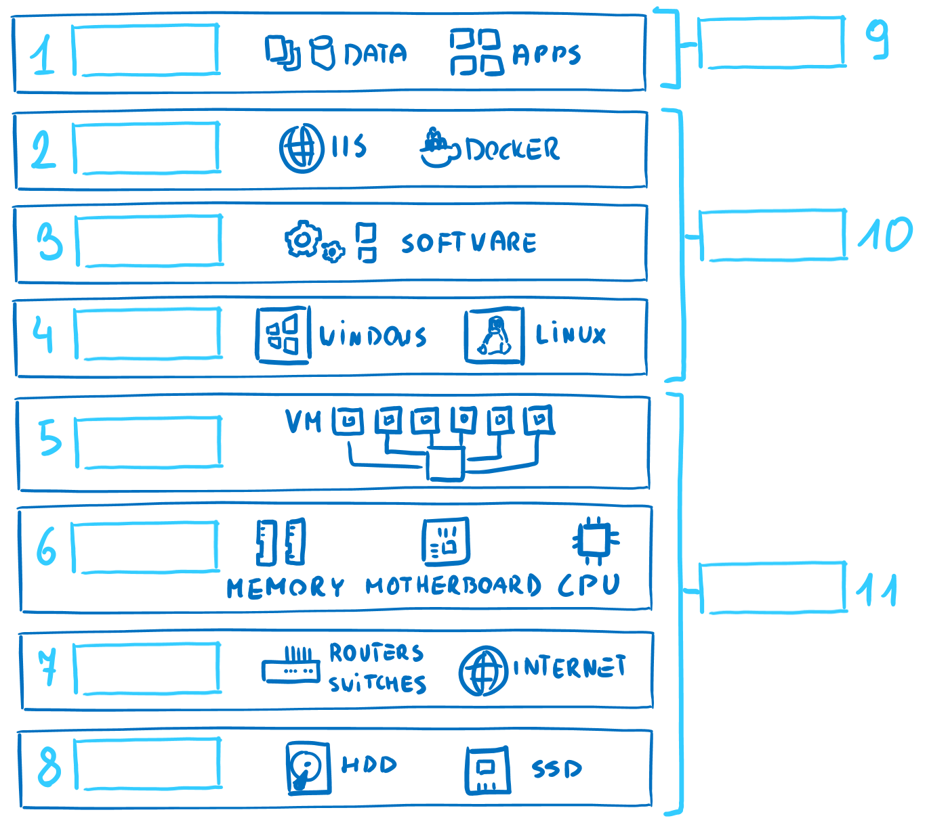
Software/platform/Infrastructure.
***region pairs have atleast 300 miles distance.
***Region pairs are static, we can not choose regions to pair with.
***Each region pair also resides with in the same geography (exception: Brazil has its region pair in US)
***Resources in a resource group can reside in a different location.
***Resources can be moved between Resource-groups.
***ARM interacts with Azure AD to check the privileges of user and thus controls the resources and its access.

***VM (IaaS) 1 node (no auto scaling)
VM scale set for auto scaling 1000 node
Container (PaaS) 20 node (no auto scaling)
Kubernetes (PaaS) 100 node
WebApi (PaaS) 20/100
Functions(PaaS) 200 nodes

Virtual Network | VPN | VPN gateway

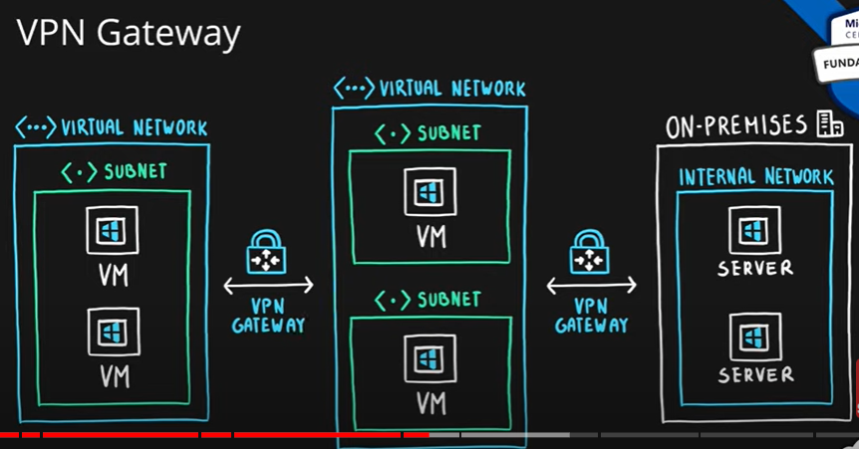
***VPN is for virtual n/w.
***VPN gateway or Vnet peering can be used to connect cross-regional vnets.

App Gateway:
***Load balancer evenly distribute non-http traffic. Whereas Application Gateway evenly distribute HTTP related traffic.

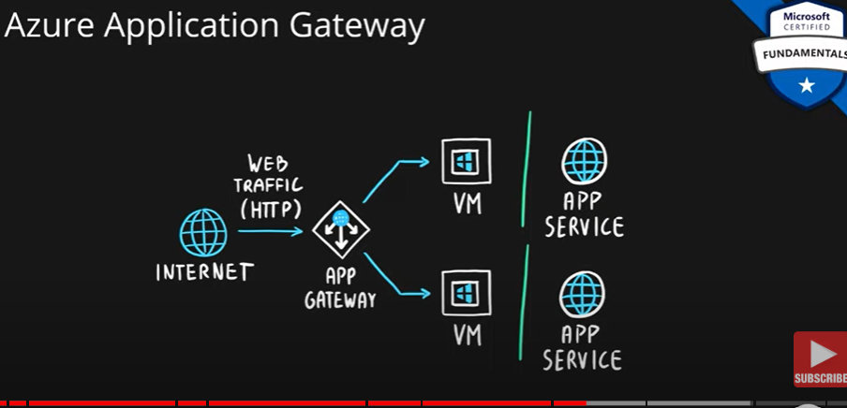

CDN
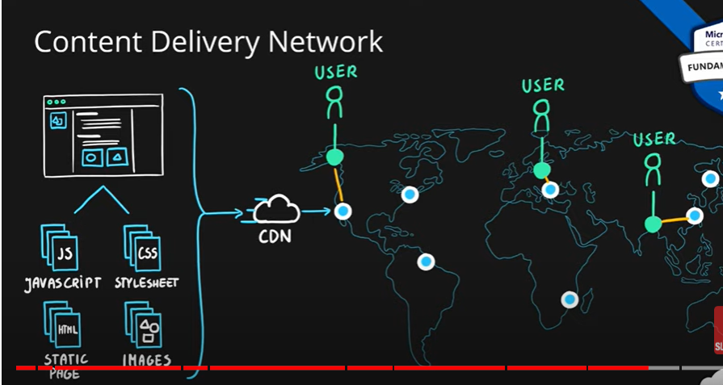

Big Data: All are PaaS
Azure Synapsys: Big data analytics, provide workspace, with the power of SQL and Spark, Data factory
HDInsight: Open source analytical service, with supported tools like Hadoop, Kafka, hive, Spark, etc.,
Azure Databricks: based on Apache Spark analytic.

***Azure Devop’s contains multiple services (boards, pipeline, repos, test plan and artifacts).

NSG/ASG
***NSG (n/w security group) = Filtering of incoming/outgoing traffic for virtual network resource.
*** Application security group=Grouping of VM located in Azure and reduce maintenance effort (like assigning explicit IP address to each VM, DB). They don’t serve the purpose of traffic filtering.
***Rules based on FQDN is possible only though Azure Firewall only.

ASC (Azure Security Center)
***centralized/unified infrastructure, platform security mgmt. service.
***integrated with Azure Advisor.

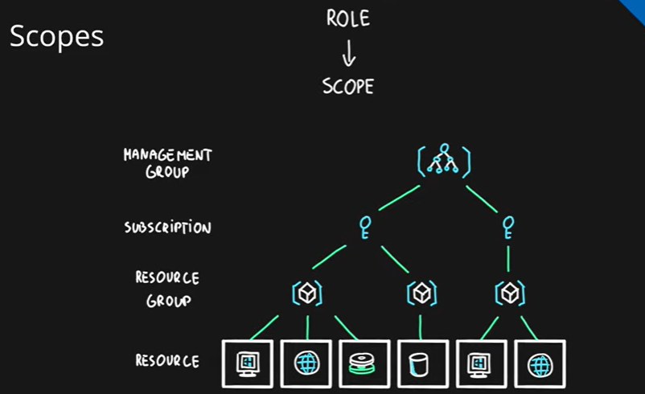
***Security principle is an Azure object (identity) that can be assigned to a role (user, group, application/service object like service principle , or managed identities)
***Role assignment=>(role def + security principal + scope)
***tags are used for (resource governance, security, operation management, cost management and automation).
***tags are applicable for Resource, Resource group and Subsciption. Tags are not inheritable.

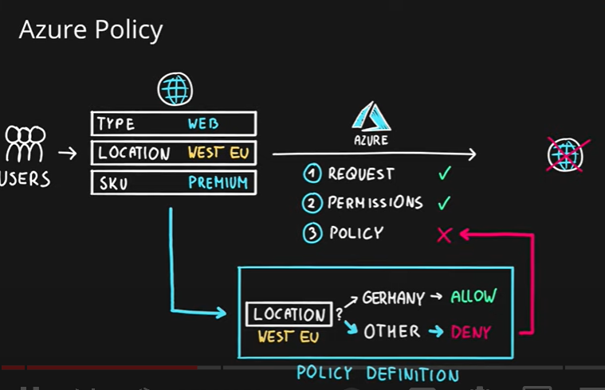
***Azure policies are inheritable.
*** Policies help with resource governance, security, compliance, cost management, etc
*** Policies focus on resource properties (RBAC focused on user actions)
***Scopes can be assigned to management groups, subscriptions, resource groups, and resources
***Policies allow for exclusions of scopes.

Blue Prints:
***Package of artifacts (policy assignment, Role assignment, ARM template, Resource group).
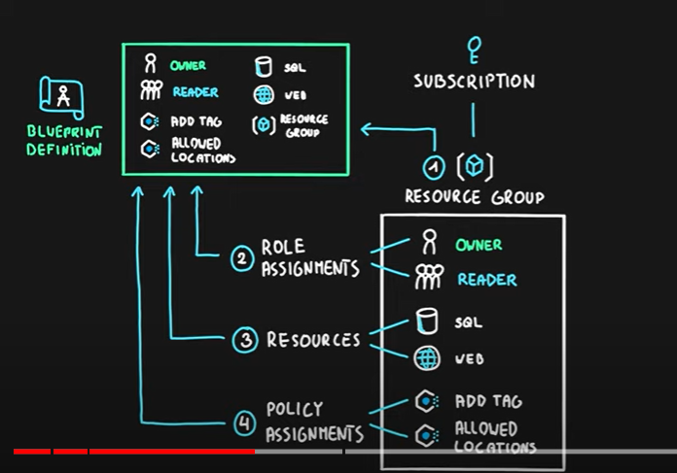

***Cloud Adoption process= plan, ready and Adopt.

***Higher tier service offer better SLA’s.
***Free service and Preview service have NO SLA, and therefore they are not recommended for production.
***composite SLA is a combination of application components.
vm + sql => sla AND sla => sla * sla
web1, web2 => sla OR sla => 100% - (unavailability (web1) * unavailability(web2))
***Public preview is a ‘beta’ stage of the service available to general public use
***Features can also be in preview stages

Additional:
***perform disaster recovery of ur vm by using Disaster recovery.
***(Availability , Downtime)
( 99.95, 22 minuted) | (99.99, 4 ½ munites) | (99.999, 26 sec)
***single instance VM, availability
(sssd ultradisk 99.9%) | (ssd managed, 99.5% ) | ( hdd managed, 95%)
Two or more instance in same Availability set, 99.95%
Two or more instance in two or more Availability Zone in same Azure region 99.99%

***Availability set, is the logical grouping of vm’s
(Fault domain: group of vm’s sharing COMMON power source and n/w switches
Update domain: group of vm’s rebooted at the same time)
***Manage cost in vm=> auto scaling(elasticity), reservations, spot instances, right region.
***If vm is stopped, are we still billed? Yes, for storage. Therefore delete all resources associated.

***container offerings: AKS (Azure Kubernetes services – managed Kubernetes service) and Azure Service Fabrics (Microsoft container Orchastrator – ‘specific to Microsoft, we will not find anywhere else ’)

***Function App: being PaaS, we don’t care about scaling. Availability etc., we just care about CODE.

***SaaS good example for CRM, ERP and document mgmt..
***PaaS, customer can only CONFIGURE (h/w, autoscaling, etc.) but cannot access VM instances.
***PaaS offers, compute, DB, IoT, Big Data, etc., services.

***Blob storage=> storgaeAcc -> Container(s) -> Blob(s)
Store massive amont of unstructured data.
3 type of Blob
Block blob : store test or image file
Append Blob: log files (ideal for append operation)
Page blob: Azure IaaS disk
Azure Data Lake Storage: Used for Analytics (stored in hierarchical)

***Storage Explorer (depreciated) – Storage Browser (preview) GUI: Free tool, to manage resource from desktop. Integrates with Azure blob | Data lake | managed disk.
***unmanaged disk are stored as “containers” in storage account (view in azure portal).
***Database:
RPO: (Recovery point object) max acceptable period of data loss
RTO: (recovery time object):Max acceptable downtime
***Consistency:
Strong consistence: all the replicas are updated same time, will be slow if many replicas exist.
Eventual consistency: asynchonus replication, different values in different replicas.
Read-after-write cons…: inserts are immediate available, but updates are eventual consisytecy.

***Relation DB
OLTP: (online trnsx processing): eg web application tranx, (eg: Banking transx, online shopping)
Store data on a row wise.
OLAP: (online analytics processing): Dataware house, for analytics, intelligence.
Store data column wise and the data is distributed over many nodes in a cluster.

***Azure Cosmo DB: schema-less, single digit response, automatic scaling(serverless), 99.999% availblty.
Support API’s for MongoDB(Document) | Cassandra (key/value) | Gremlin (graph).
***In-memory database: Redis deliver microsecond latency. caching, gaming, session mgmt.
***DDoS attack:
Basic : Enabled by default, no extra cost.
Standard: mitigates 60 different DDoS attack. Receive credit, if attack is not mitigated .

***Private link and private endpoint: This is used to connect between our resources in vnet. Example a private link is established between webapplication and Database with in the subnet or across the subnet.
***Hybrid cloud: VPN (encypted over public internet) connection between on-premise and cloud.
Need VPN gateway in Virtual n/w.
:ExpressRoute (private physical wired ) connection between on-premise and cloud.

*** Network Security Group (NSG) is like a internal firewall inside your Virtual Network right before your resources. You can configure multiple inbound and outbound security rules to allow or block traffic based on source/destination IP address, protocol and port.

=> Azure Firewall is a managed network security service to control traffic in and out of a Azure Virtual Network

*** Resource group can’t be nested but, Management Group (above subscription) can be nested.

A tag applied to ResourceGroup can’t be automatically applied to resource, but policy and roles are inheritred. A ResourceGroup and ManagemenntGroup are not charged. Account can have multiple subscription and multiple account administrators. Two subscriptions can not be merged, but resources can be moved between subscriptions and resource group (of same subscription), However, you cannot move resource group between scubsciptions as they are tied fit to initial subscription. If a subscription expires, you can not create resource, BUT, you can access data in it.

***All subscriptions in a management group should be associated with same Azure AD tenant.

***Azure subscriptions can be created using either a Microsoft account or a work account (also known as an organizational account) that is associated with Azure Active Directory (Azure AD).
***Azure Subscriptions can have more than one account administrators.
***When you convert a Free Trial to a Pay-As-You-Go subscription in Azure, all the resources that you have created during the Free Trial will continue to exist and function normally.

***CSPM(cloud security posture mgmt.) automate identification and remediation of ur cloud config.

CWP(cloud workload protection)continuously moniotor and fix threat to ur workload.

Microsoft Cloud Defender: uses above and formerly called ‘Azure Security center’.

***Azure AD provide 99.9%availablity SLA (premium edition).

***Conditional access available with Azure AD (P1 & P2) licenses. Provide granular MFA experience based on signals.

***You can change/move the directories of a subscription.

***Azure AD (web based protocols: OAuth, SAML, Open ID) vs AD(Kerberos, LDAP, NTLM).

***Multiple subscriptions can trust the same Azure AD directory.

Each subscription can trust only one directory.

You can transfer an Azure subscription to a different Azure AD directory.

When an subscription expires, associated Azure AD tenant is not deleted, u can link it with diff sub.

***As we saw in the Demo for Azure Defender for Cloud, Advanced Features are NOT Free. However you can try them using the 30-day free trial. But basic feature is free.

***Advisor: improve reliability, security, performance, operational excellence and cost.

Take immediate action or schedule or dismiss. Give total score.

Reliablity: protect your VM data from accidental deletion.(idebtify vm where backup isin’t available)

: create Azure Service health alert.

Cost optimization: optimize vm spend by resizing or shutingdown underutilized instance.

: optimize spend for MYSQL and other DB’s by right sizing.

: delete unassociated public IP address and use life-cycle management(hot, cold..)

***Monitor: gather, analyze from logs and metrics. It monitors our application and infrastructure.

Application insight: detect and diagnose application issues.

Vm insight : monitor performcne & health of vm’s and vm scale set.

Container insight : monitor performance of container workload (AKS, ACI).

Log analytics : troubleshoot issue using monitoring data from logs.

Create smart alerts : sms, email etc., and attempt to automatically take corrective actions.

Create visualization using Azure Dashboard.

***Azure service health:

Set up service health alert via email, sms, push nitification, webhook, etc.,

Hierarchy: Azure status > Azure Service health > Azure resource health.

Azure status: Global view of Azure health (google using Azure status and view the status of resources

Azure service health: cutsimzed notification to see if any issues with Azure services (service is not us

Azure respource health: provide info. About heath of our resource created eg:vm instance

Health history.

***Azure policy:

Help in rules creating for (resource, regions, etc), tag all resource, MFS should be mandatory, etc.,

Existing non-complaint resource will be marked as non-compliant, but they continue to work as is.

Policy evaluation is not immediate, but runs for approx. every one hour.

***Blueprint=one or more (policy, role, ARM template, Resource group)

Your Architect team can create blueprint based on organization std, pattern requirement.

***Compliance:

Azure compliance hub: link

Azure security and compliance blueprint: easily create environment compliance with std.

Azure compliance manager: Automated complete lifecycle mgmt., (risk, implement cntrl, audit, etc.,)

***Azure Information Protection helps you to classify and protect your documents and emails. You can add labels indicating what kind of protection/encryption you want.

***Consumption based Vs Fixed pricing

Consumption based: You pay for what you use, eg: Functions.

Fixed price: billed for instance, whether u use or not, eg: vm instance, App service (even if don’t

***Cost management:

Set up a budget based on filters (eg: tags)

Set up alerts for a threshold and notifications.

*** You can access Azure portal from Windows, Linux and MacOS. But, you can create only Windows and Linux on Azure vm’s but can’t install MacOS on vm’s.

